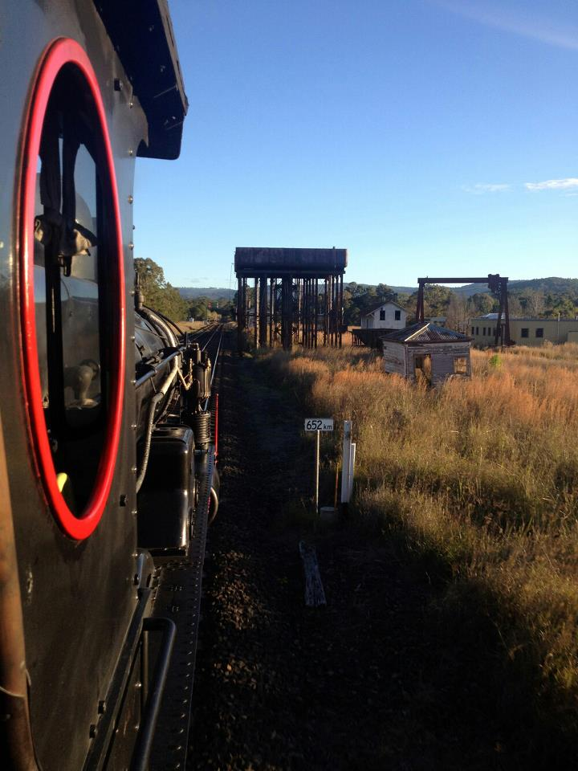
LACHLAN VALLEY RAILWAY
OPERATIONS PLAN AND TOUR BRIEF

{INSERT EVENT NAME}
{Insert Train Name}
{Insert Tour Start and Finish Dates}

Lachlan Valley Railway Society Co-operative Limited
Locomotive Depot, Campbell Street, COWRA
PO Box 279, COWRA NSW 2794
Phone (02) 6342 4999 Fax (02) 6341 3599
Web www.lvr.com.au Email inquiries@lvr.com.au

ABN 33 678 338 351

Contents
Tour Scope 3
Overview 3
Passenger Train Operations 3
Empty car movement/s 3
Background 4
Tour Description 4
Customer Information 4
Further Information 4
Event Rules 4
Traction 5
Consists 5
Network Manager/s Documentation 5
Additional/Altered Train Arrangements 5
LVR Safeworking Crew 6
Train crew sleeping arrangements 6
PLATFORM STOPS 6
Guard Duties ON VRJ Tours (Remove if Not Needed) 7
The Guard must also advise the Guest Attendants the cars that will be used for alighting and boarding at that Platform (Refer table in previous section). 7
When Train Arrives at a Platform 7
If a planned carriage is not on the platform 7
When all Guests are off the Train 8
IMPORTANT 8
When Guests Arrive back at Train 8
Train crewing arrangements 8
Passenger attendant arrangements 9
First Aid Qualified Crew on Tour 9
Location of First Aid Equipment 9
Special Instructions 9
Non-Retention Toilets 9
NON Interlocked Points 9
Examination, maintenance, preparation, provisioning, servicing and stabling 10
FUELING OF LOCOMOTIVES AND POWER VANS 10
Watering & tanking of rolling-stock 10
REMOVAL OF Effluent from rolling-stock 11
Carriage Doors 11
On Board Emergency Procedures 11
TRAIN Evacuation 11
Emergency Evacuation Plan 12
Risk Managent Plan 12
incident management plan 12
Incident on the Network 12
Other incident involving LVR workers or Assets 12
Fire 13
SECURITY MANAGEMENT 13
Operator environmental management plan 13
Passenger Attendants 13
Personal protective equipment 14
Radio communications 14
Timetabled Stops 14
Contingency planning 14
Late running services 14
Failure 14
Failure single unit operation 15
Recovery from Total Failure 15
Communications 16
ARTC NCCS Junee Network Control 16
ARTC NCCN Broadmeadow Network Control 17
CRN Network Control 18
Sydney Trains/NSW Trains Network Control 19
LVR Internal Communications 23
LVOP’s and Procedures 24
LVOP’s Depot and general 24
LVOP’s Preparation of trains 24
LVOP’s Shunting 24
LVOP’s Operation of trains 25
LVOP’s Emergency working 25
LVOP’s LVR Controlled Sidings 25
Diagrams 26
Full Train Diagram (Sleeping Trains Only) 27
Tour Specific Risks 28
Signoff by Crew (Online Form May Be Used) 29

Tour Scope

Overview
Date (Revenue Service) {Insert Date}
Departure Time {Insert Departure Time}
Event {Insert Event Type}
Event Opens N/A
Event Closes N/A
Crowd Estimates N/A
Location {Insert Destination Location}
Organisation {Insert Organisation Requesting Service, or LVR}
Passenger Numbers {Insert Passenger Numbers}
Ticketing {Insert How Tickets Were Sold}
Tickets purchased on the day? No
On Board Catering Yes, LVR Internal

Passenger Train Operations
Revenue Service XXXX – XXXX
XXXX – XXXX

Empty car movement/s
Non-Revenue Service XXXX – XXXX
XXXX – XXXX
XXXX – XXXX
XXXX – XXXX

Background

Tour Description
{Brief description of tour, enough information to allow customer facing staff to understand intention and history of the tour}

Customer Information
Charterers {Charterer Name – If applicable}
Email {Charterer Email – If applicable}
Phone {Charterer Phone – If applicable}

Further Information
Name | Organisation | Contact | Role

Event Rules
{Insert any special Instructions in this area}

Traction
Lachlan Valley Railway Society Co-operative Limited will operate;
{Highlight what is necessary below – delete this sentence)
Option 1 Diesel Locomotive/s and Carriages
Option 2 Steam Locomotive/s and Carriages
Option 3 CPH Railmotor/s

Consists
Type | 1 | 2 | 3 | 4 | 5 | 6 | 7 | 8 | 9
Locomotives
Carriages
Railmotors | CPH | CPH | CPH

Consist | Vehicles | Tonnes Trailing | Total Tonnes | Total Length | Max Speed
Consist 1
Consist 2
*Crew must observe all speeds either lineside, CAN notified or defined in the TOC/RAS manual

Network Manager/s Documentation
ARTC TAA No. XXXX-20XX
UGLRL CTN No. XXXX-20XX
RailCorp/Sydney Trains STN No. XXXX-20XX
Train Crew will be advised of any ADHOC paths.

Additional/Altered Train Arrangements
ARTC TAA No. 0000-2019
UGLRL CTN No. 0000-2019
RailCorp/Sydney Trains STN No. 0000-2019

LVR Safeworking Crew
Name | Organisation | Contact | Role
Please refer to the LVR Roster for shift times, instructions and other information

Train crew sleeping arrangements
Name | Carriage No. | Room No.
TBA

PLATFORM STOPS
Location | Platform Length | Ensure the following is on the Platform

Guard Duties ON VRJ Tours (Remove if Not Needed)
When 30 mins before a scheduled stop the Guard must transmit the following message on the Guest Attendants Radio;
"Guard to Guest Attendants, we are half an hour till arrival at <destination> Guard to Guest Attendants, we are half an hour till arrival at <destination>"

The Guard must also advise the Guest Attendants the cars that will be used for alighting and boarding at that Platform (Refer table in previous section).
Guest Attendants will not respond to this message.

When Train Arrives at a Platform
Once Stationary, the Guard will transmit the following message;
"Guard to Guest Attendant unlock doors"
Guest Attendants - If they can see a platform, they will unlock but NOT open doors.
The Guard will inspect the platform for safety and when satisfied will transmit the following message;
"Guard to Guest Attendant open doors"
Guest Attendants - Open and facilitate Guests onto platform (being mindful of the gap).

If a planned carriage is not on the platform
"Guest Attendant to Guard, door <state carriage letter> is not on platform."
Guest Attendants – Lock the door and move guests to the next available carriage with platform access.

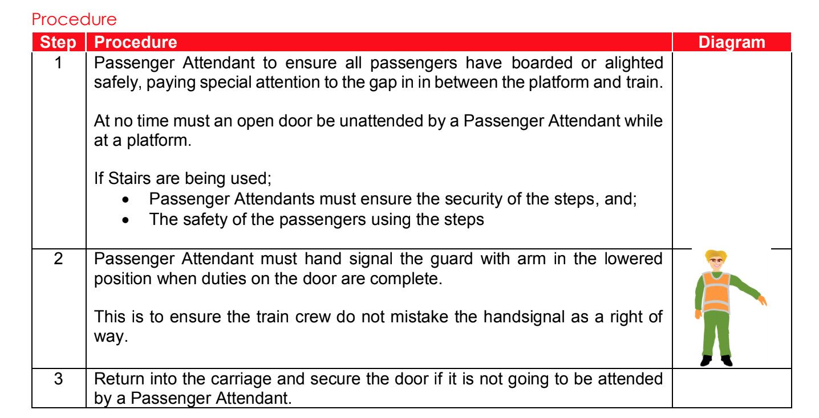
When all Guests are off the Train

IMPORTANT
- If you have no reason to alight during this period, stay on the train.
- Never get off the train unless on a platform (or if the Guard has assessed the risk)
- If in the Rail Corridor do not approach other railway lines and stay well clear.
- Never open an external door while the train is moving (even when moving slightly)

When Guests Arrive back at Train
Guard – Sound Whistle as warning of an impending departure time
Guest Attendants - welcome Guests back onto train (being mindful of the gap).
Guest Attendants - visually check the Platform for guests.
Guest Attendants - Signal Guard (as shown in Page 8 Procedure) when clear.
Guest Attendants - Locks Door
Guest Attendant to contact Guard only if there is an issue.

Train crewing arrangements
Services will be crewed by LVR members/volunteers and rostered in compliance with the Rail Safety National Law and LVR Rostering procedures.
If any train crew are suffering from the effects of fatigue, drugs or alcohol it is an offence to sign on.

Passenger attendant arrangements
Services will be crewed by LVR members/volunteers and rostered in compliance with the Rail Safety National Law and LVR Rostering procedures by the On-Board Services Manager.
If any passenger attendants are suffering from the effects of fatigue, drugs or alcohol it is an offence to sign on.

First Aid Qualified Crew on Tour
At a minimum LVR Tours shall have one First Aid Qualified person on a train, record the name and contact of the person/s below
Name |  | Contact | Role

*Ensure the people listed above are identified on the crew roster as holding First Aid

Location of First Aid Equipment
{Insert the location of First Aid Equipment on train}

Special Instructions
{Insert any Special Instructions Required on the Tour Here}

Non-Retention Toilets
Non retention toilets must be locked off or otherwise inaccessible to Passengers and Crew. Non retention toilets must never be used.

NON Interlocked Points
The Following Non-Interlocked Points must be secured before LVR Service enters a yard provided with Non-Interlocked Points.
Location | Arrangements
Orange | All Facing points
XXXX | XXXX

If any Crew Member are unfamiliar with a Yard or Siding that must be accessed, they must STOP the movement and not resume until the area is assessed and all required points are secure. TRAILING POINTS IS PROHIBITED.

Examination, maintenance, preparation, provisioning, servicing and stabling
Whenever examination and servicing is to take place on/or near adjacent to running lines, Train Crew and maintenance staff must contact the relevant Network Controller and implement Absolute Signal Blocking.
Maintenance staff must ensure all documentation related to the operation of an LVR service is successfully completed prior to the tour.

Location | Arrangements
Large Erecting Shop | Pre Trip Inspection
XXXX | XXXX
XXXX | XXXX
Record any maintenance that must be undertaken.

FUELING OF LOCOMOTIVES AND POWER VANS
Location | Date | Arrangements | Contact Details
Orange |  | Fuel in LVR Depot | XXXX XXX XXX
XXXX |  |  | XXXX
XXXX |  |  | XXXX

Watering & tanking of rolling-stock
Location | Date | Arrangements | Contact Details
LES |  | Hose Taps | XXXX XXX XXX
XXXX |  |  | XXXX
XXXX |  |  | XXXX

Watering must not take place unless required protection is in place and train will not move.

REMOVAL OF Effluent from rolling-stock
Location | Date | Arrangements | Contact Details
LES | 21/5/2021 | 21:30hrs Gary’s De-Pooing | 0400 000 000
XXXX |  |  | XXXX
XXXX |  |  | XXXX

REMOVAL OF WASTE/RUBBISH FROM ROLLINGSTOCK
Location | Arrangements
Orange | Use of Station Bins
XXXX | XXXX
XXXX | XXXX

Carriage Doors
Carriage Doors must be locked if a train is not standing at a platform unless attended by a Passenger Attendant. If the Passenger Attendant must leave the door it shall be locked.

On Board Emergency Procedures
The first point of contact in an emergency should be the Network Controller

If passengers or crew are sleeping onboard Passenger Attendants are responsible for ensuring all passengers or crew are briefed in the Emergency Evacuation Plan.
For emergency procedures on sleeping trains refer to LVR F 106 for further information

TRAIN Evacuation
Plans to evacuate a train to the rail corridor must be reported to Network Control before any evacuation order is given (unless passenger safety is in doubt).
Never evacuate to a live track or anywhere that puts passenger safety in doubt.
The Operations Supervisor (if provided) or Guard will come to an arrangement with the Driver on the location and side of the train to undertake the evacuation.
Sleeping trains must have at least two points of evacuation at opposite ends of the consist identified to Passengers and Crew

Emergency Evacuation Plan
If an Emergency Evacuation Plan is to be used it must be provided in Sleeper cabins (for Passengers) or in common areas and kept as part of the briefing if only crew are staying onboard. Each location a train stables overnight must be assessed for risk to safety of crews.
Diagrams are to use text as large as possible to ensure clarity to the reader.
Local Emergency Services will be contacted and advised on the location of the train while stabled in case a need arises to respond to a situation.
Emergency Service |  | Contact | Location (if more than one)
Police |  | XX XXX XXX
Fire |  | XX XXX XXX
Ambulance |  | XX XXX XXX

Risk Managent Plan
See documents contained within the LVR Master Document Register or Risks and identified controls in the LVR Risk Register.
If anyone identifies a hazard or a risk during the tour must report it to the manager and via the following link;
Link to LVR Hazard Report

incident management plan

Incident on the Network
Incidents will be managed in accordance with relevant Network Manager’s Network Rules and Procedures.

Other incident involving LVR workers or Assets
If anyone identifies an incident or injury during the tour must report it to the manager and via the following link;
Link to LVR Occurrence Report
Incidents will be managed in accordance with LVRS Operator Specific Procedures, (‘LVOP’s’) and SMS Emergency Response, (Incident/Environmental Management) Plan.

Fire
In the event of an LVRS service fire.
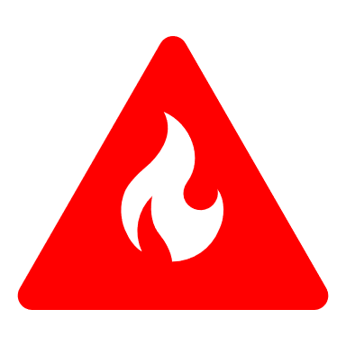
All fires in the rail corridor must be immediately reported to Network Control
If a fire is detected it must be immediately reported to the Guard
Fires to be reported to the relevant Network Manager’s Network Control Officer/s and managed in accordance with LVOP 604 and LVOP 614.
Safeworking Crews must remain vigilant of the risk of tall dry grass on sidings especially when operating Rail Motors or any other rollingstock that has low hanging machinery.

SECURITY MANAGEMENT
Any anti-social behaviour, criminal or potential terrorist related activity must be reported to the Guard, Operations Manager or LVR Director ASAP.
Activity causing immediate threat to LVR, passengers or the public must be reported to 000.
All security issues must be reported using the LVR Occurrence Report
Other responses should be consistent to LVR G 001 Occurrence Response Guide
All LVR workers must ensure no unauthorised access to LVR stable locations or rollingstock by members of the public. Competent workers must also ensure rolling stock that will be left unattended is secured against unauthorised access/use.
LVR monitors the National Terrorism Threat Level and it is currently at;
PROBABLE

Operator environmental management plan
All waste/s from LVRs train operations are retained in appropriate containers/retention tanks fitted to rolling stock. LVRS responsibly disposes of all waste/s generated by operations.
Do not dump and/or leave rubbish, ash or any other waste from LVR Trains.

Passenger Attendants
Ensure all non-retention toilets on the train remain locked (CPH 25)
When the Guard has blown his whistle for departure do not leave the train
Safety kits and cleaning kits on board train

Personal protective equipment
PPE including high visibility vests and appropriate safety footwear required
High visibility vests to be worn at all times when not on train and not on a platform

Radio communications
Driver and Guard to use discrete LVRS radio channel when possible
Do not pass sensitive information across the WB train Radio Channel

Timetabled Stops
Trains will operate in accordance with attached Train Schedule Reports.

Contingency planning

Late running services
All LVR workers must ensure that services run as close to the timetable as possible (unless influenced by safety related matters)
LVRS qualified worker Train Crew will notify relevant Network Manager’s Network Control Officer/s as soon as possible to minimise disruption to the network.

Failure
In the event of an LVRS service failure.
Sufficient motive power is available to ensure that any service can be worked to a crossing loop or destination.
In the case of this tour spare traction will be located at Lithgow.

Failure single unit operation
Alternate arrangements will be as determined by relevant Network Manager’s Network Control Officer/s, qualified worker Train Crew and the Operations Manager.

Recovery from Total Failure
Location | Bus Operator | Contact | Mechanical Recovery | Contact
XXXX | Jones Bros Bus | (02) 6352 3888 | LRW | 0429 140 654

Communications

ARTC NCCS Junee Network Control
Manager | Contact number
Train Transit Manager | 02 6924 9809

Board | Area of control | Contact Number
Sydney 1 | Botany Yard (inclusive) to Enfield South (exclusive) | 02 6924 9806  02 6924 9866 emergency
Sydney 2 | Enfield (inclusive) including Enfield Yard to Flemington Jct (exclusive) Chullora Jct Enfield West (inclusive) to Leightonfield (inclusive) / Sefton Park Jct (exclusive) | 02 6924 9804  02 6924 9864 emergency
Sydney 3 | Leightonfield (exclusive) to Glenlee (inclusive) Glenlee (inclusive) to Berrima Junction (exclusive) Mittagong Junction to Braemar | 02 6924 9803  02 6924 9863 emergency
Main South A | Berrima Junction (inclusive) to Harden (exclusive) / Moss Vale (inclusive) to Unanderra (exclusive) | 02 6924 9807  02 6924 9867 emergency
Main South B | Harden (inclusive) to Albury (exclusive) / Cootamundra West (inclusive) to Stockinbingal (inclusive) | 6924 9808  02 6924 9868 emergency
Main South C | Albury (inclusive) to Somerton Vic (inclusive) / Benalla (inclusive) to Oaklands (inclusive) | 026924 9802  02 6924 9862 emergency
Main South D | Medway Junction exclusive to Harden (exclusive)  0700-1500 Monday to Friday only | 02 6924 9805  02 6924 9865 emergency
TOCO | Broken Hill to Stockinbingal (exclusive) and Bogan Gate to Bogan Gate North | 02 6924 9801  02 6924 9861 emergency
Coast A | Telarah (exclusive) to Kempsey (exclusive) | 02 6924 9811  02 6924 9871 emergency
Coast B | Kempsey (inclusive) to Acacia Ridge (exclusive) / Number 1 Down Home Signal | 02 6924 9812  02 6924 9872 emergency

ARTC NCCN Broadmeadow Network Control
Manager | Contact number
Train Transit Manager | 02 4902 9410

Board | Area of control | Contact Number
Terminal Coordinator | Port Waratah and Kooragang Island | 0408 616 692
Port Waratah | Islington & Port Waratah (inclusive) to Sandgate (exclusive) | 02 4902 7907  02 4902 7967 emergency
Kooragang | Sandgate (exclusive) Kooragang Island (inclusive) | 02 4902 7906  02 4902 7966 emergency
Lower Hunter | Sandgate (inclusive) to Allandale (exclusive) Telarah & Bloomfield Branch line (inclusive) | 02 4902 7909  02 4902 7969 emergency
Middle Hunter | Allandale (Inclusive) to Singleton (inclusive) Mt Thorley – Bulga – Wambo Branch lines (inclusive) | 02 4902 7908  02 4902 7968 emergency
Upper Hunter 1 | Singleton (exclusive) to Mangoola (exclusive) and Aberdeen (exclusive) | 02 4902 7910  02 4902 7970 emergency
Upper Hunter 2 | Aberdeen (inclusive) to Werris Creek (exclusive) | 02 4902 7911  02 4902 7971 emergency
Upper Hunter 3 | Mangoola (inclusive) to Gulgong (exclusive) | 02 4902 7905  02 4902 7965 emergency
North | Werris Creek (inclusive) to Turrawan (inclusive) | 02 4902 7902  02 4902 7962 emergency
TOCO | Goobang Junction (exclusive) to Gulgong (inclusive) via Dubbo & Merrygoen Merrygoen (exclusive) to Werris Creek / Gap (exclusive) | 02 4902 7916  02 4902 7976 emergency
TOCO | Turrawan (exclusive) to Moree Moree to North Star Camurra to Camurra West (inclusive)  0700-1500 Monday to Friday only | 02 4902 7903  02 4902 7963 emergency

CRN Network Control
Board | Area of control | Contact Number
South West | Stockinbingal (exclusive) to Lake Cargelligo  Ungarie to Naradhan  Temora to Hillston  Junee (exclusive) to Griffith  The Rock (exclusive) to Boree Creek  Joppa Junction (exclusive) to Canberra  Bogan Gate North to Tottenham  Narromine (exclusive) to Cobar (Also CSA & Elura)  Nevertire to Warren | 02 4028 9502  02 4028 9542 emergency
North West | Orange East Fork (exclusive) to Parkes (exclusive)  Orange (exclusive) to Dubbo exclusive  Narrabri West Yard (inclusive) to Walgett  Burren Junction to Merrywinebone  Camurra West to Weemelah  Baal Bone Junction (exclusive) to Kandos  Werris Creek (exclusive) to Armidale | 02 4028 9501  02 4028 9541 emergency
West | Wallerawang (inclusive) to Orange inclusive  Wallerawang (inclusive) to Baal Bone Junction (inclusive)  Parkes Yard | 02 4028 9504  02 4028 9544 emergency

Sydney Trains/NSW Trains Network Control
Rail Management Centre Sydney | Contact number
RMC Shift Manager | 0418 161 287  02 9379 1743
RMC Operations Control Supervisor | 0418 270 073  02 9379 4664

Board | Area of control | Contact Number
Goods 1 | Flemington Markets Clyde Up Yard Meeks Road Jcn | 02 9379 4733
South Coast | Sutherland (exclusive) to Bomaderry (Nowra) | 02 9379 4559
North Outer | Cowan (exclusive) to Islington Junction (exclusive) | 02 9379 4519
West Outer | Emu Plains exclusive to Lithgow (inclusive) | 02 9379 4224

Area | Signal Box | Position | Workstation Panel | Contact
STHI | Sydney Yard | Yard Controller | Sydney Yard Office | 02 9379 1009
STHI | Sydney Yard | Ass. Yard Controller | Sydney Yard Office | 02 9379 1938
STHI | Sydney Yard | Sydney Yard Shunter | Sydney Yard Terminal | 02 9379 1938
STHI | Macdonaldtown | Signaller | Macdonaldtown QE | 02 9379 1741
STHI | Macdonaldtown | Signaller | Macdonaldtown QE | 0439 649 660
NTH | Homebush | Area Controller | Sydney Yard | 02 9701 1558
NTH | Homebush | Area Controller | City Underground | 02 9701 1501
NTH | Homebush | Area Controller | Sydney Illawarra | 02 9701 1562
NTH | Homebush | Area Controller | Sydney East Down | 02 9701 1588
NTH | Homebush | Area Controller | Sydney East Up | 02 9701 1581

The new Sydney assist Table telephone numbers provided at Homebush Control Centre are 94036 (internal) 02 9379 4036 (external) and 71531 (internal) 02 9701 1531 (external).

The new Sydney Yard Signaller fax number will be 25544 (internal) 02 9752 8544 (external) provided for the Sydney Yard signaller at Homebush Control Centre.

WN 28-09 July 2018.

Area | Signal Box | Position | Workstation Panel | Contact
NTH | Homebush | Asst Signal Box Mgr. | Homebush Office | 02 9752 6007
NTH | Homebush | Shift Supervisor |  | 02 9701 1516
NTH | Homebush | Area Controller | North Desk | 02 9701 1584
NTH | Homebush | Area Controller | West Desk | 02 9701 1577
NTH | Homebush | Area Controller | Epping | 02 9701 1580
NTH | Homebush | Area Controller | Nth Shore/Nth Sydney | 02 9701 1528
NTH | Homebush | LICS Operator | North LICS | 02 9701 1545
NTH | Homebush | LICS Operator | Inner West LICS | 02 9701 1560
NTH | Homebush | Area Controller | Hornsby Main | 02 9701 1510
NTH | Homebush | Area Controller | Hornsby North | 02 9701 1513
NTH | Homebush | Area Controller | Auburn | 02 9701 1587
NTH | Homebush | Area Controller | Flemington | 02 9701 1551
NTH | Homebush | Area Controller | Lidcombe | 02 9701 1550
NTH | Homebush | Area Controller | Strathfield | 02 9701 1552

Area | Signal Box | Position | Workstation Panel | Contact
STHI | Sydenham | Asst Signal Box Mgr. | Sydenham Office | 02 9563 7139
STHI | Sydenham | Shift Supervisor |  | 02 8568 3415
STHI | Sydenham | Area Controller | ESR | 02 8568 3491
STHI | Sydenham | Area Controller | Sydenham | 02 9563 7137
STHI | Sydenham | Area Controller | Wolli Creek | 02 9563 7596
STHI | Sydenham | Area Controller | Hurstville | 02 9563 7454
STHI | Sydenham | Area Controller | Sutherland | 02 9563 7453
STHI | Sydenham | Area Controller | Sefton | 02 9563 7973
STHI | Sydenham | Area Controller | Revesby | 02 8568 3467
STHI | Sydenham | Area Controller | Glenfield | 02 8568 3442
STHI | Sydenham | Area Controller | Liverpool | 02 9563 7875
Meeks Road XPT Centre |  | Shift Manager |  | 02 9563 7741

Area | Signal Box | Position | Workstation Panel | Contact
STHI | Waterfall | Signaller | Waterfall | 02 9522 1218
STHI | Wollongong | Area Controller | Wollongong North | 02 4223 5446
STHI | Wollongong | Area Controller | Wollongong | 02 4223 5538
STHI | Wollongong | Area Controller | Wollongong South | 02 4223 5599
STHI | Wollongong | Area Controller | Wollongong Coast | 02 422 35766
STHI | Berry | C/A -Q | Berry | 02 4223 5644
STHI | Bomaderry | Nowra C/A -Q | Bomaderry Nowra | 02 4423 0141

Area | Signal Box | Position |  | Workstation Panel |  | Contact
STHI | Fairfield | C/A -Q | Fairfield |  | 02 9765 1642
STHI | Campbelltown | Signaller | Campbelltown |  | 02 4629 0883

Area | Signal Box | Position | Workstation Panel | Contact
NTH | Berowra | C/A -Q | Berowra Station | 02 9847 8531
NTH | Gosford | Area Controller | Gosford | 02 4349 9263
NTH | Gosford | Signaller | Gosford | 02 4349 9120
NTH | Wyong | Signaller | Wyong | 02 4923 0921
NTH | Morisset | C/A -Q | Morisset | 02 4349 9320
NTH | Fassifern | C/A -Q | Fassifern Station | 02 4954 1201
STNTH | Broadmeadow | Area Controller | Broadmeadow Panel | 02 4923 0901
 | Broadmeadow | Grade 1 Signaller | Broadmeadow Panel | 02 4923 0904
STNTH | Broadmeadow | Area Controller | Newcastle Panel | 02 4923 0990

Area | Signal Box | Position | Workstation Panel | Contact
WST | Clyde | Signaller | Clyde | 02 9848 9211
WST | Parramatta Rd | Signaller | Parramatta Rd | 02 9848 9261
WST | Granville | Signaller | Granville | 02 9848 9242
WST | Granville | Signaller | Westmead | 02 9848 9666
WST | Blacktown | Area Controller | Blacktown | 02 9851 7207
WST | Blacktown | Area Controller | Richmond | 02 9851 7323
WST | Blacktown | Signaller | Katoomba | 02 9851 7401
WST | St Marys | Signaller | St Marys | 02 9851 7209
WST | Penrith | Signaller | Penrith | 02 4780 3824
WST | Mt Victoria | Signaller | Mt Victoria | 02 6354 9837
WST | Lithgow CS | Signaller | Lithgow Coal Stage | 02 6352 0540
WST | Lithgow Yard | Signaller | Lithgow Yard | 02 6352 0855

LVR Internal Communications
Name | Organisation | Contact | Role
Ross Jackson | LVR | 0477 753 820 | Chairman/Director, Rail Safety
John Healey | LVR | 0414 448 870 | Director, Secretary/Treasurer
Cass Mendham | LVR | 0411 790 021 | Director, Facilities
Ben Semple | LVR | 0437 021 275 | Director, On Board Services
Benn Eagle | LVR | 0408 416 964 | Director, Maintenance
Jack Holmes | LVR | 0448 262 926 | Director, Operations
Thomas Barnes | LVR | 0432 786 775 | Director, Volunteers

LVOP’s and Procedures
Number | Name | Link to Document
LVOP 100 | Table of contents | Link
LVOP 102 | Introduction | Link

LVOP’s Depot and general
Number | Name |  | Link to Document
LVOP 200 | First aid kits | Link
LVOP 202 | Operation of Turntable | Link
LVOP 204 | Work on track within depot | Link
LVOP 208 | Trip diary | Link
LVOP 210 | Security management | Link
LVOP 212 | Safety briefings prior to operations | Link
LVOP 214 | Procedure for the filing of train running details | Link

LVOP’s Preparation of trains
Number | Name | Link to Document
LVOP 300 | Preparation of LVRS trains | Link
LVOP 302 | Preparation of Steam Locomotives | Link
LVOP 304 | Operation and management of braking systems | Link

LVOP’s Shunting
Number | Name | Link to Document
LVOP 400 | Procedure for shunting | Link
LVOP 402 | Screw couplings & transition links | Link
LVOP 404 | Emergency coupler procedure 620 / 900 class | Link
LVOP 406 | Riding on external vehicle steps prohibited | Link
LVOP 408 | Shunting movements with passengers on board | Link
LVOP 410 | Propelling movements | Link
LVOP 412 | Setting back at platforms | Link
LVOP 414 | Stabling trains with passengers on board | Link
LVOP 416 | Stabling of Locomotives and Carriages | Link

LVOP’s Operation of trains
Number | Name | Link to Document
LVOP 500 | Train crew vigilance |  | Link
LVOP 502 | Crowd control at Outstations |  | Link
LVOP 504 | Limit of people in Locomotive cabs |  | Link
LVOP 505 | Limiting distractions in cabs |  | Link
LVOP 506 | Bell Signals |  | Link
LVOP 508 | Metropolitan train running |  | Link
LVOP 510 | Train crew right away procedure |  | Link
LVOP 512 | Cross calling of signals, signs and indicators |  | Link
LVOP 514 | Non acceptance of verbal assurances |  | Link
LVOP 516 | Level crossings |  | Link
LVOP 518 | Operation of CPH Railmotors in traffic |  | Link
LVOP 520 | Operation and management of Steam Locomotives |  | Link
LVOP 522 | Protection of staff conducting maintenance |  | Link

LVOP’s Emergency working
Number | Name | Link to Document
LVOP 600 | Passing signals at stop |  | Link
LVOP 602 | Train exceeding limit of authority |  | Link
LVOP 604 | Fire on or about trains in the rail corridor |  | Link
LVOP 606 | Passenger alarms and evacuation to track |  | Link
LVOP 608 | Injury and incapacitation of passengers |  | Link
LVOP 610 | Injury and incapacitation of train crew |  | Link
LVOP 612 | Response to fatalities and trauma |  | Link
LVOP 614 | Response to incidents and reporting |  | Link
LVOP 616 | Dealing with disabled trains |  | Link

LVOP’s LVR Controlled Sidings
Number | Name | Link to Document
LVOP 800 | Procedures for Rothbury Siding |  | Link

Diagrams

Full Train Diagram (Sleeping Trains Only)

Tour Specific Risks
Hazards, issue or topic  (e.g. Site specific hazards identified, changes to procedures, documents, plant or equipment) | Controls  (to be implemented to eliminate or reduce the risk to the lowest practicable level, or action required by workers) | Responsible for Control

Signoff by Crew (Online Form May Be Used)
All incidents and injuries must be reported to the Rail Safety Manager or Director
All persons listed below acknowledge that they:
(Briefer to delete and initial any items that are not applicable)
1) that I am in possession of a safety vest
2) that I am wearing suitable footwear
3) that I am carrying my Identity card
4) that I possess the relevant qualifications for the position I am rostered for
5) that I have read a copy of the safety critical documentation, if applicable
6) that I have read and understood LVOPs applicable to the position I am rostered for
7) that I will obey all instructions given by the Operations Safety Officer of the Day
8) that I am aware of the conditions set out in the Rail Safety Law with respect to Fatigue Management
9) that I have read and understood LVR Fatigue Policy and am fit for duty as per that policy
10) that I have read and understood LVR Drug & Alcohol Policy and am fit for duty as per that policy
11) that I understand if I identify a hazard on the tour I must report it immediately to my supervisor
Name | Signature | Position | Date

